**Assignment No:-34**

Name:-Suryawanshi Sangramsingh Sambhaji

Batch: - Delta - DCA (Java) 2024 Date:-23/6/2024

**1. Write a Java program to add two matrices of the same size.**

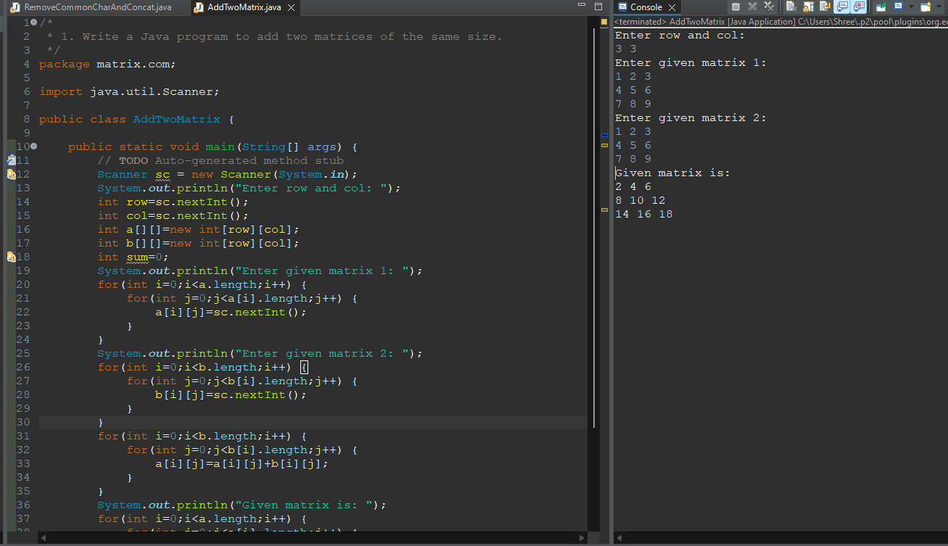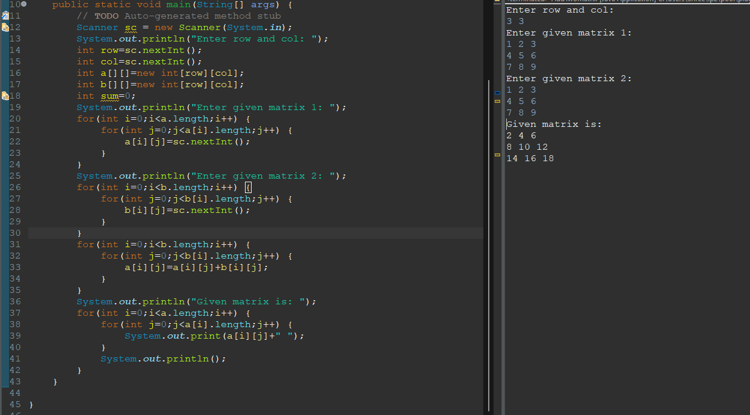

**2. Write a Java program to multiply two matrices.**

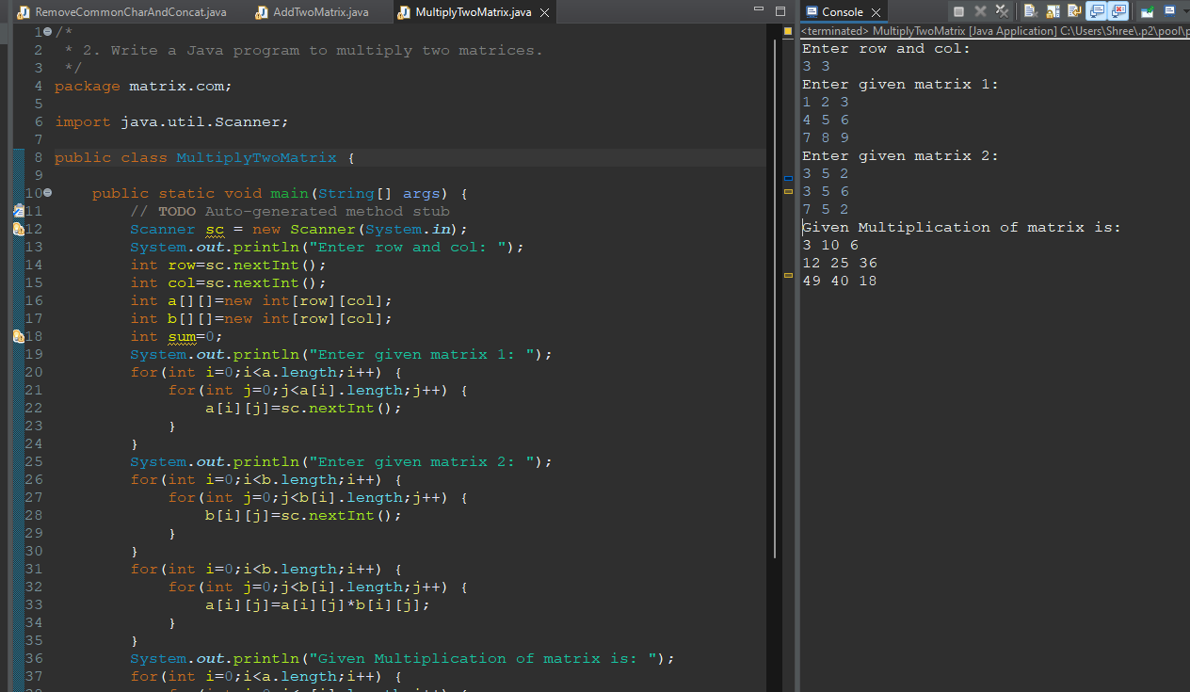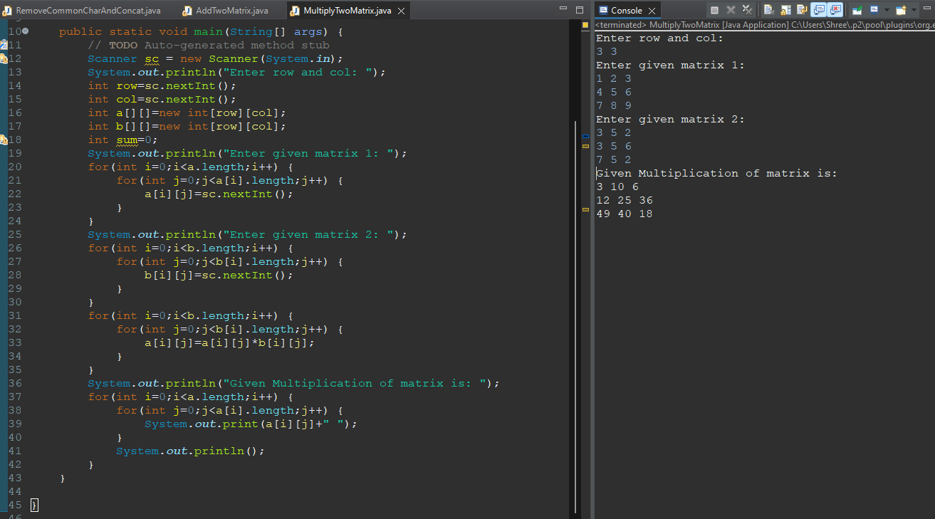

**3. Write a Java program to find the transpose of a matrix.**

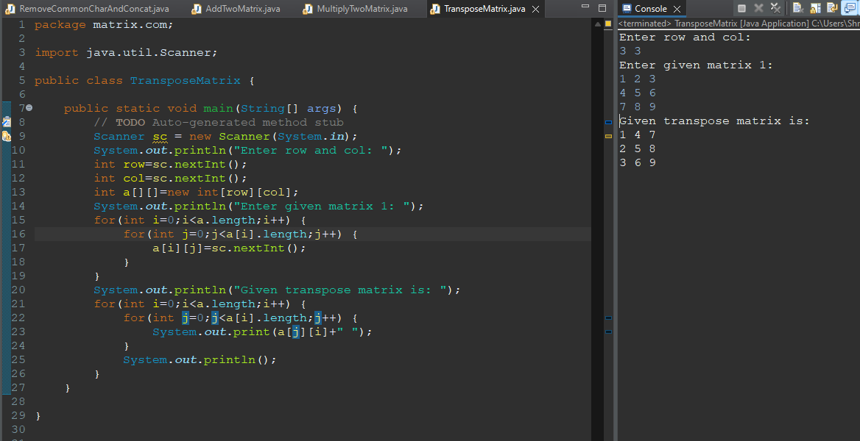

**4. Write a Java program to check if a matrix is symmetric.**

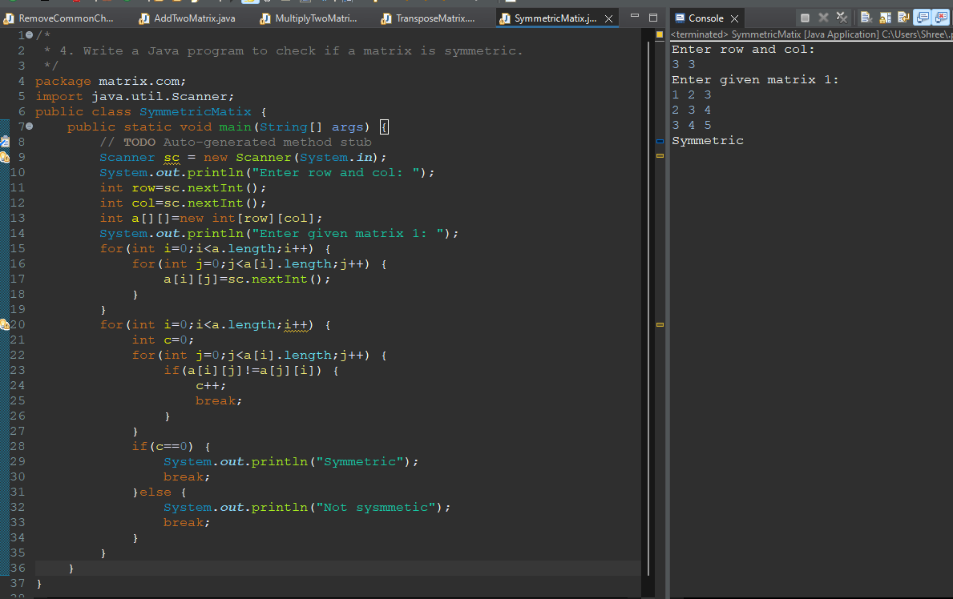

**5. Write a Java program to check if a matrix is diagonal.**

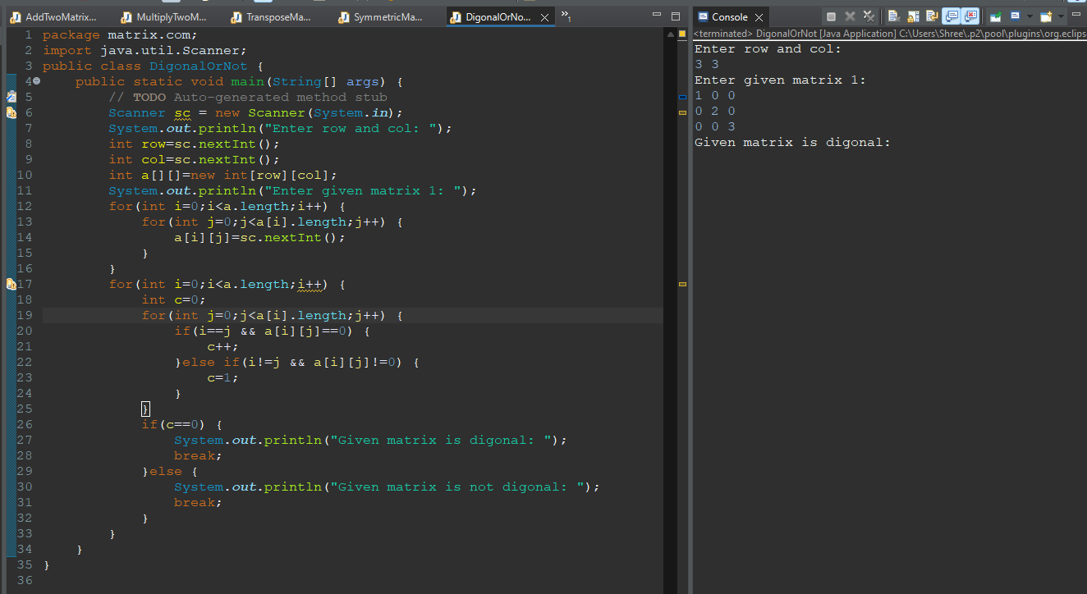

**6. Write a Java program to find the sum of the diagonal elements of a matrix.**

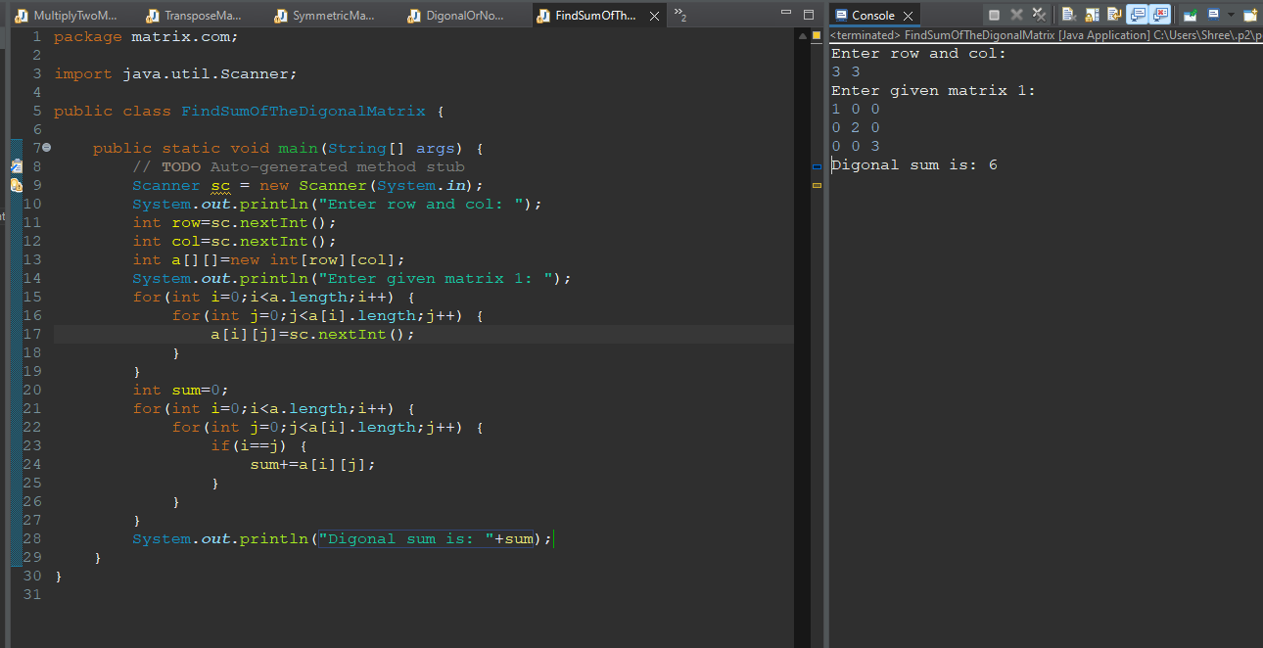

**7. Write a Java program to find the product of diagonal elements of a matrix.**

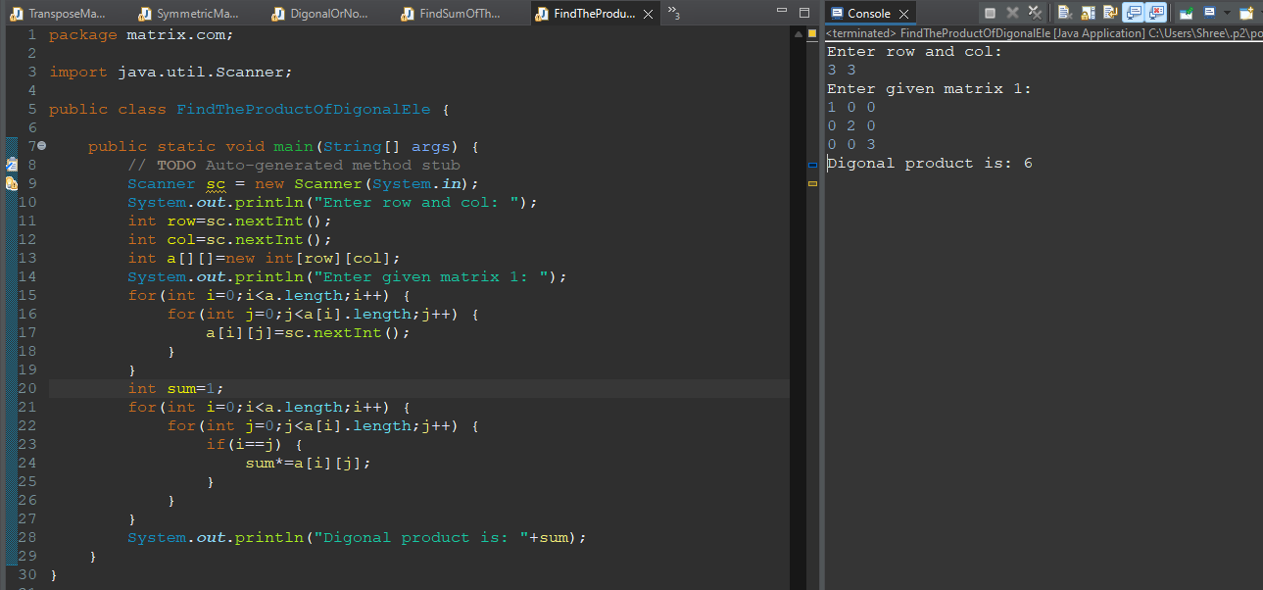

**8. Write a Java program to find the sum of each row and column of a matrix.**

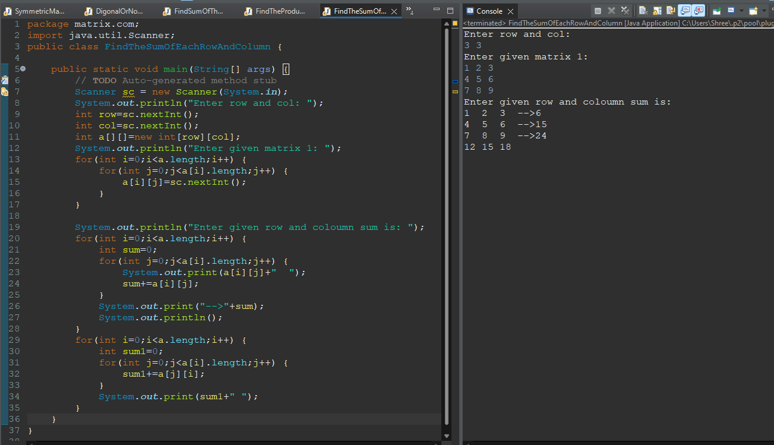

**9. Write a Java program to find the maximum element in a matrix.**

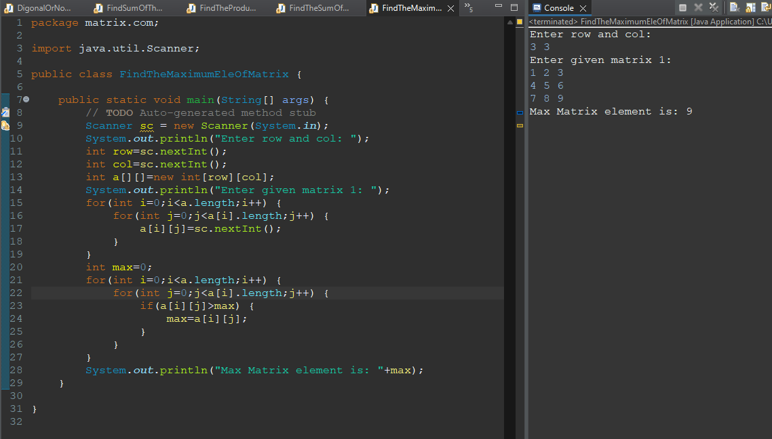

**10. Write a Java program to find the minimum element in a matrix.**

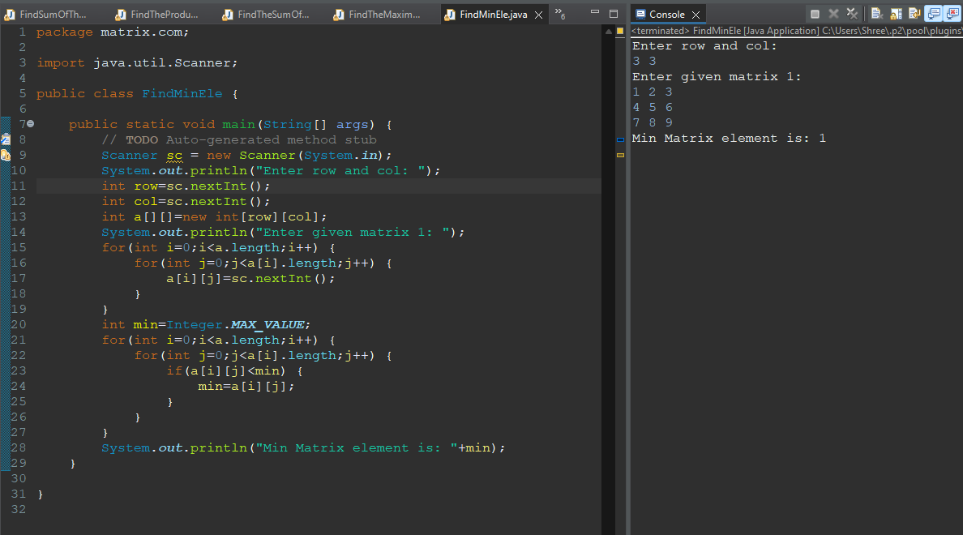

**11. Write a Java program to sort the elements of each row of a matrix.**

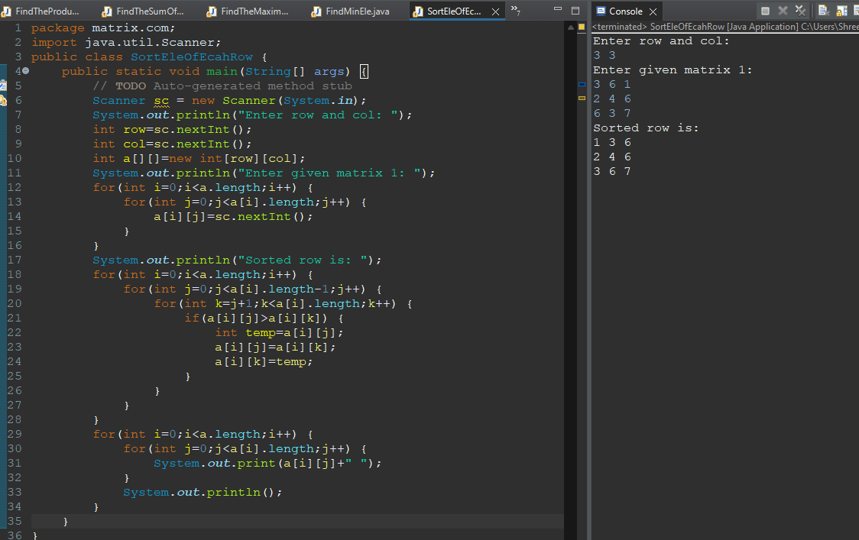

**12. Write a Java program to find the saddle point of a matrix.**

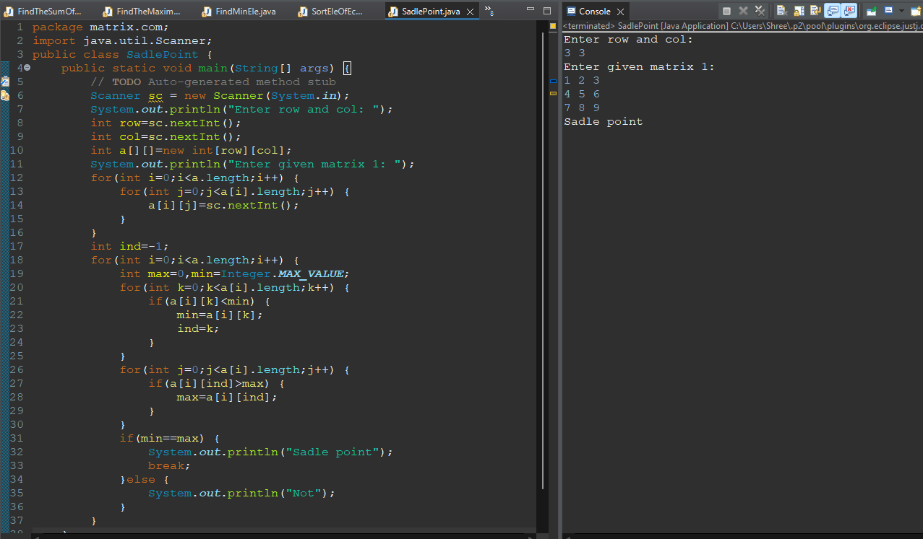

**13. Write a Java program to find the frequency of a given element in a matrix.**

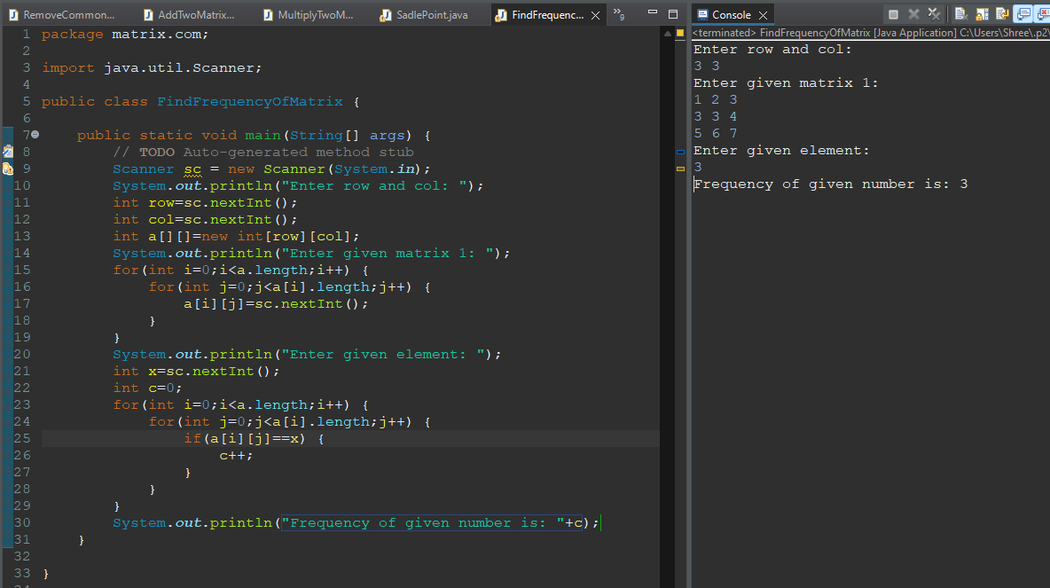

**14. Write a Java program to rotate a matrix by 90 degrees clockwise.**

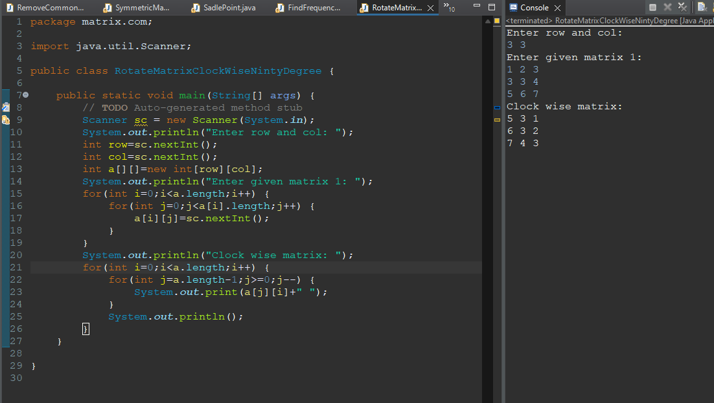

**---------------------------------------------------------------------------------------**

**1: Implement a function to rotate a square matrix (2D array) by 90 degrees in clockwise direction.**

**Example:**

**Input:**

**[[1, 2, 3],**

**[4, 5, 6],**

**[7, 8, 9]]**

**Output:**

**[[7, 4, 1],**

**[8, 5, 2],**

**[9, 6, 3]]**

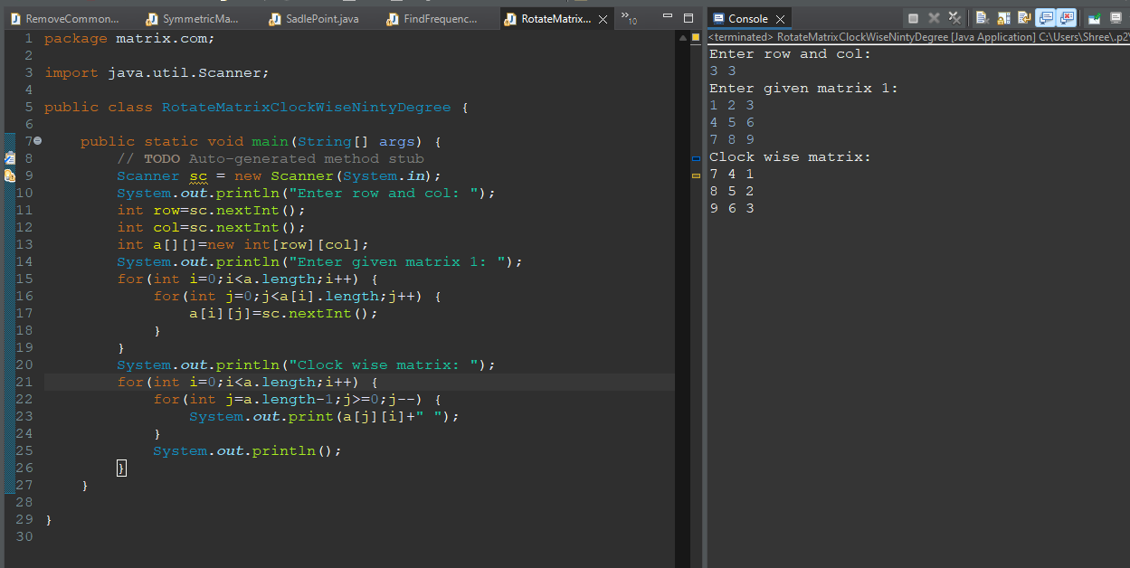

**2: Given a matrix of integers, write a function to find the median of the matrix. The matrix is sorted in non-decreasing order both row-wise and column-wise.**

**Example:**

**Input:**

**[1, 3, 5],n=9 m=**

**[2, 6, 9],**

**[3, 6, 9]**

**Output: 5**

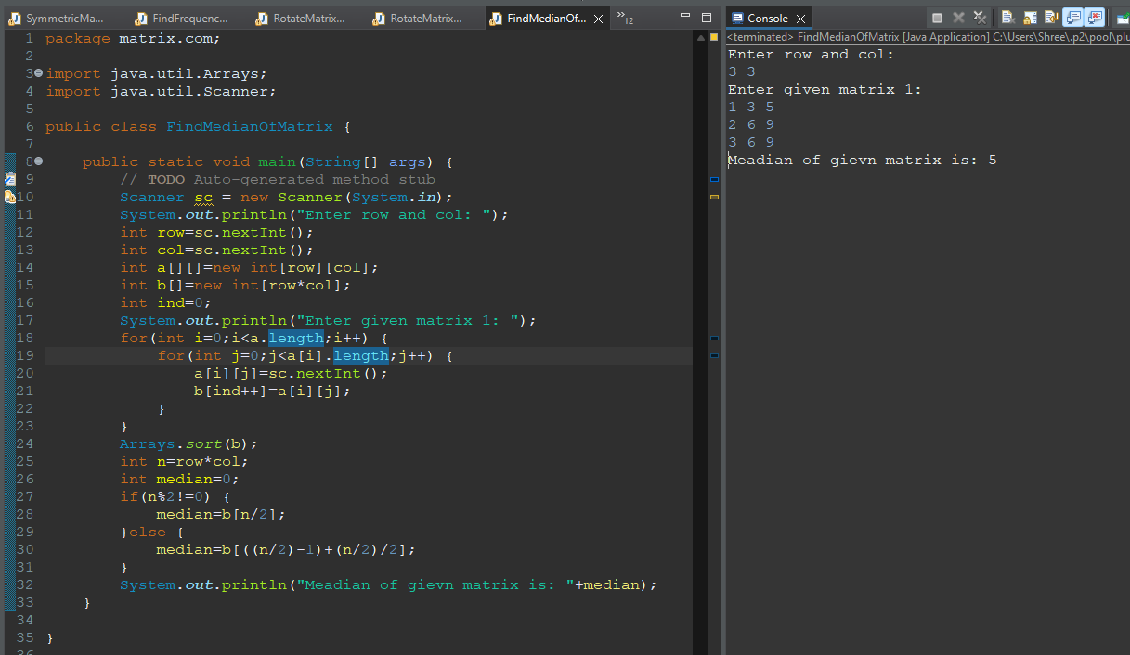

**3. Given a matrix of integers, write a function to find the kth smallest element in the matrix. The matrix is sorted in non-decreasing order both row-wise and column-wise.**

**Example:**

**Input:**

**[[1, 5, 9],**

**[10, 11, 13],**

**[12, 13, 15]]**

**k = 8**

**Output: 13**

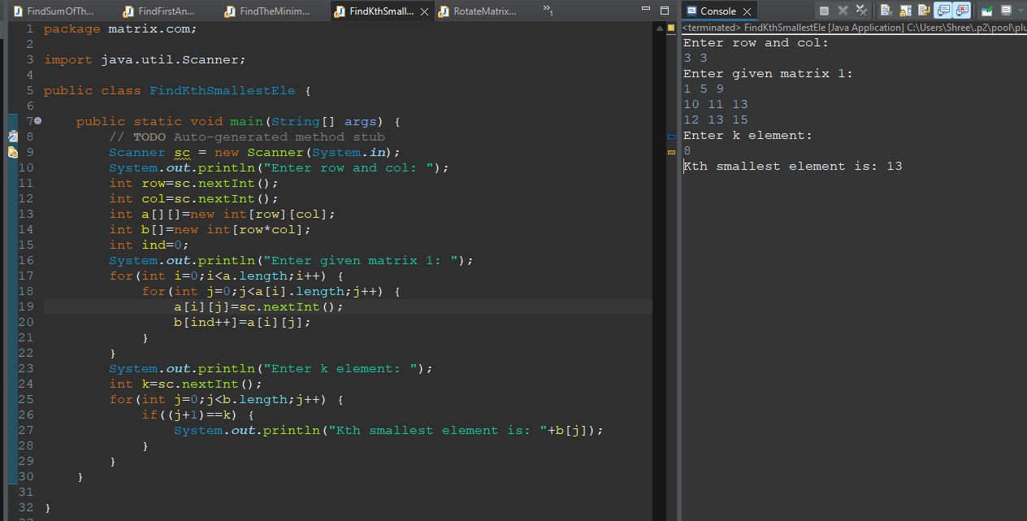

**4. Given a matrix of integers, write a function to rotate it counter-clockwise by 90 degrees.**

**Example:**

**Input:**

**[[1, 2, 3],**

**[4, 5, 6],**

**[7, 8, 9]]**

**Output:**

**[[3, 6, 9],**

**[2, 5, 8],**

**[1, 4, 7]]**

